Arsh Vohra

Azure ML assignment

Steps:

Launching ML workspace

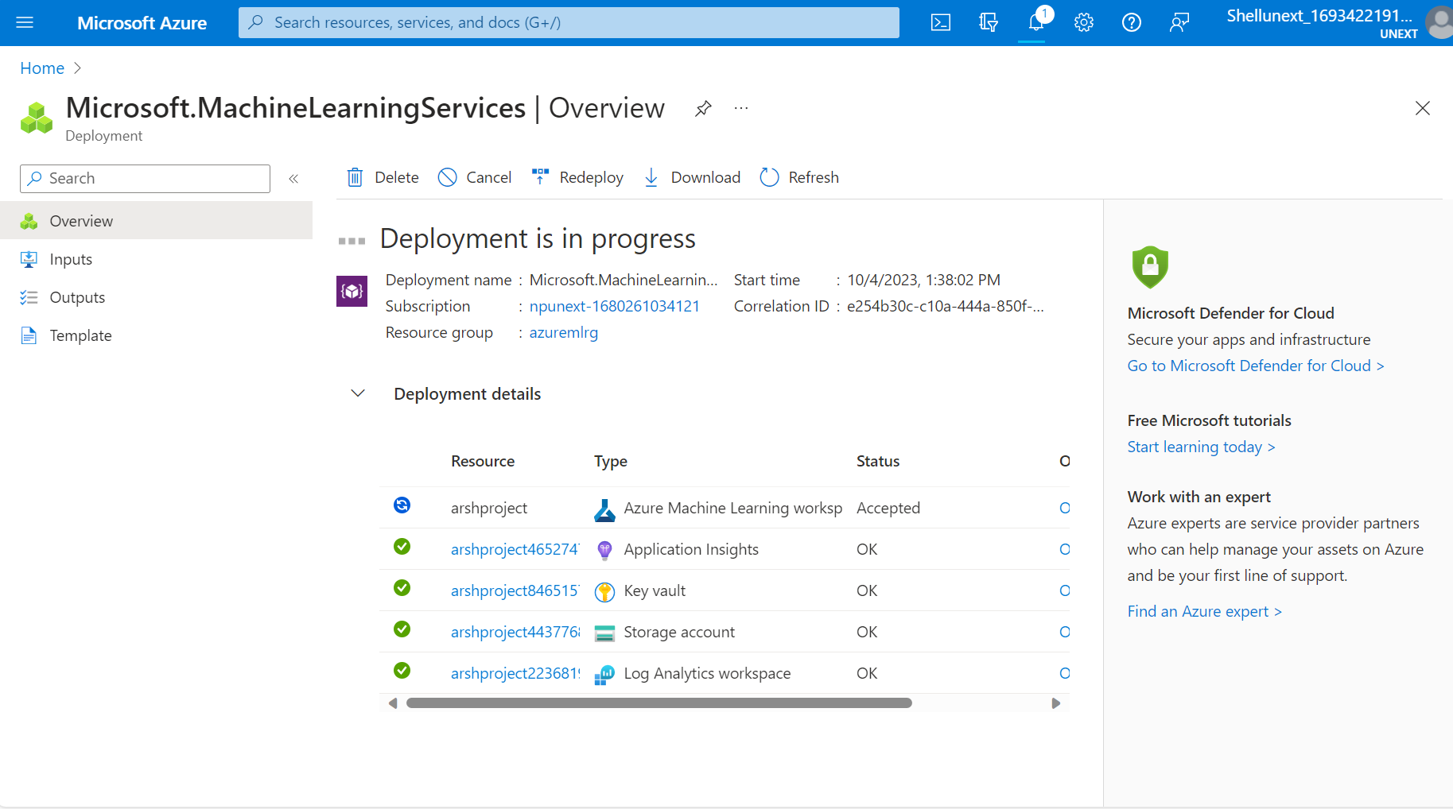

**Data Preparation**

1. Uploading csv file in blob storage account

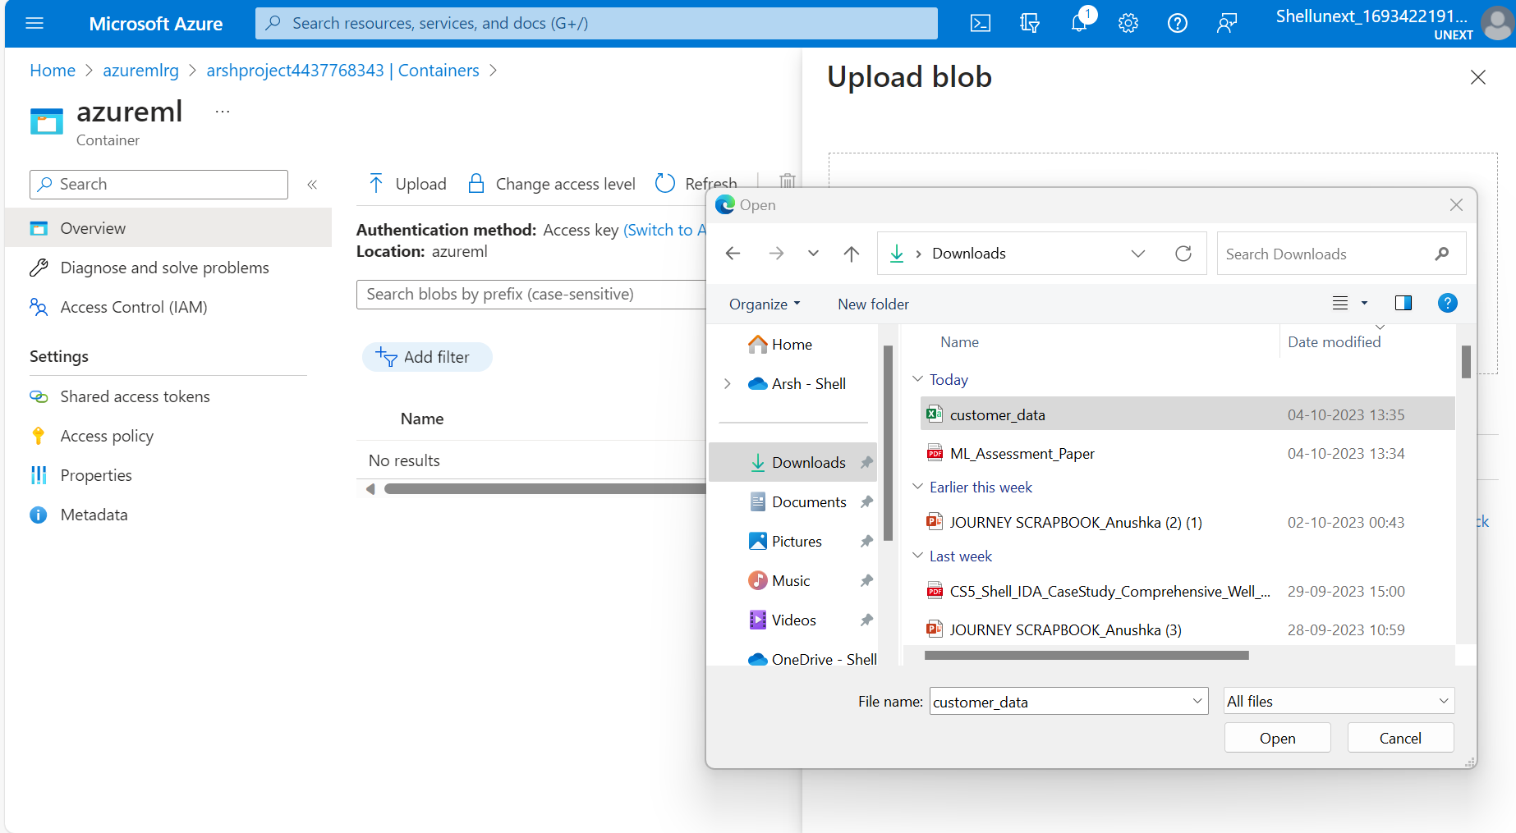

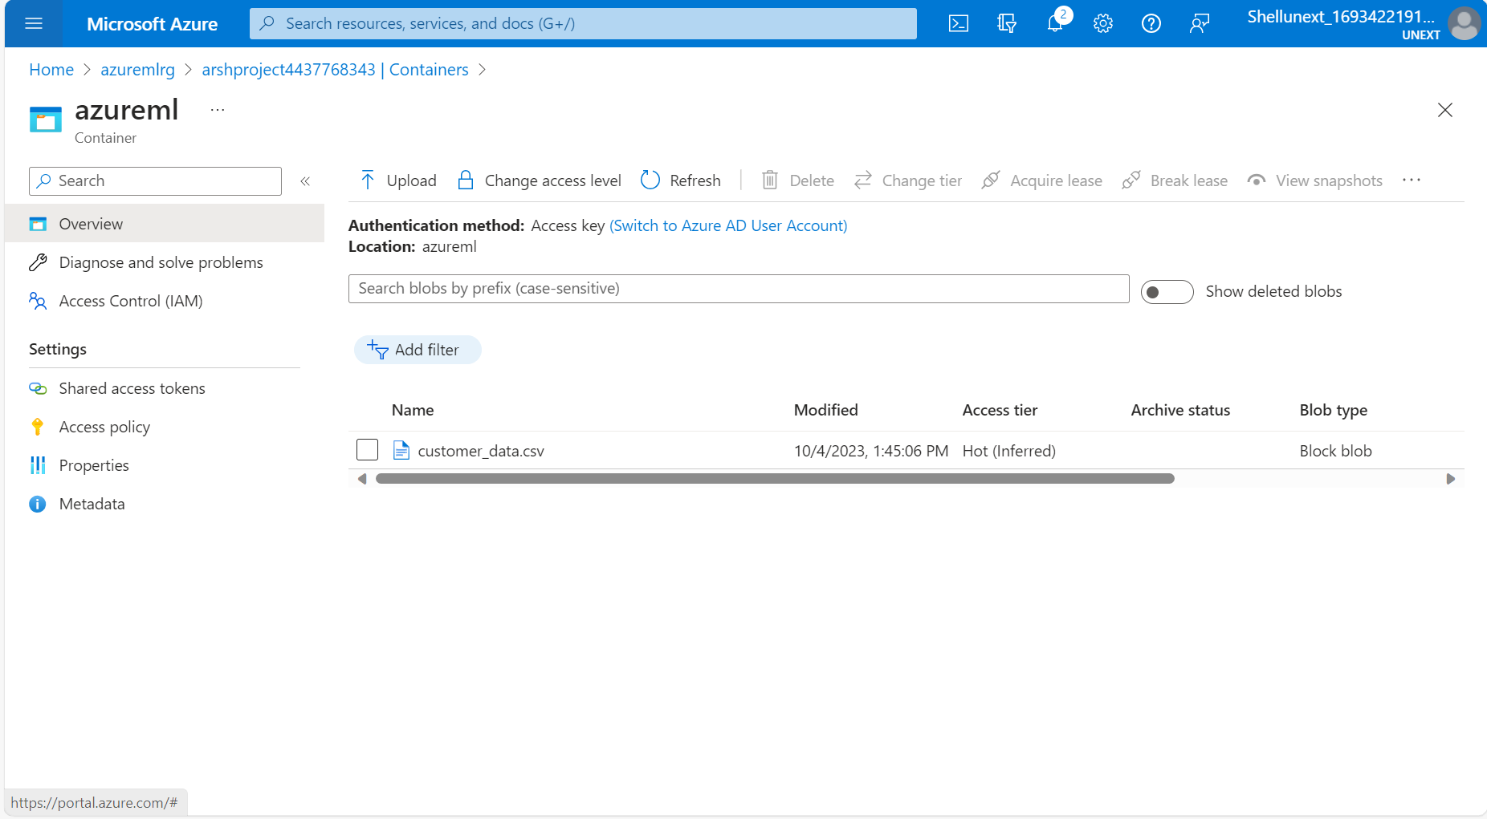

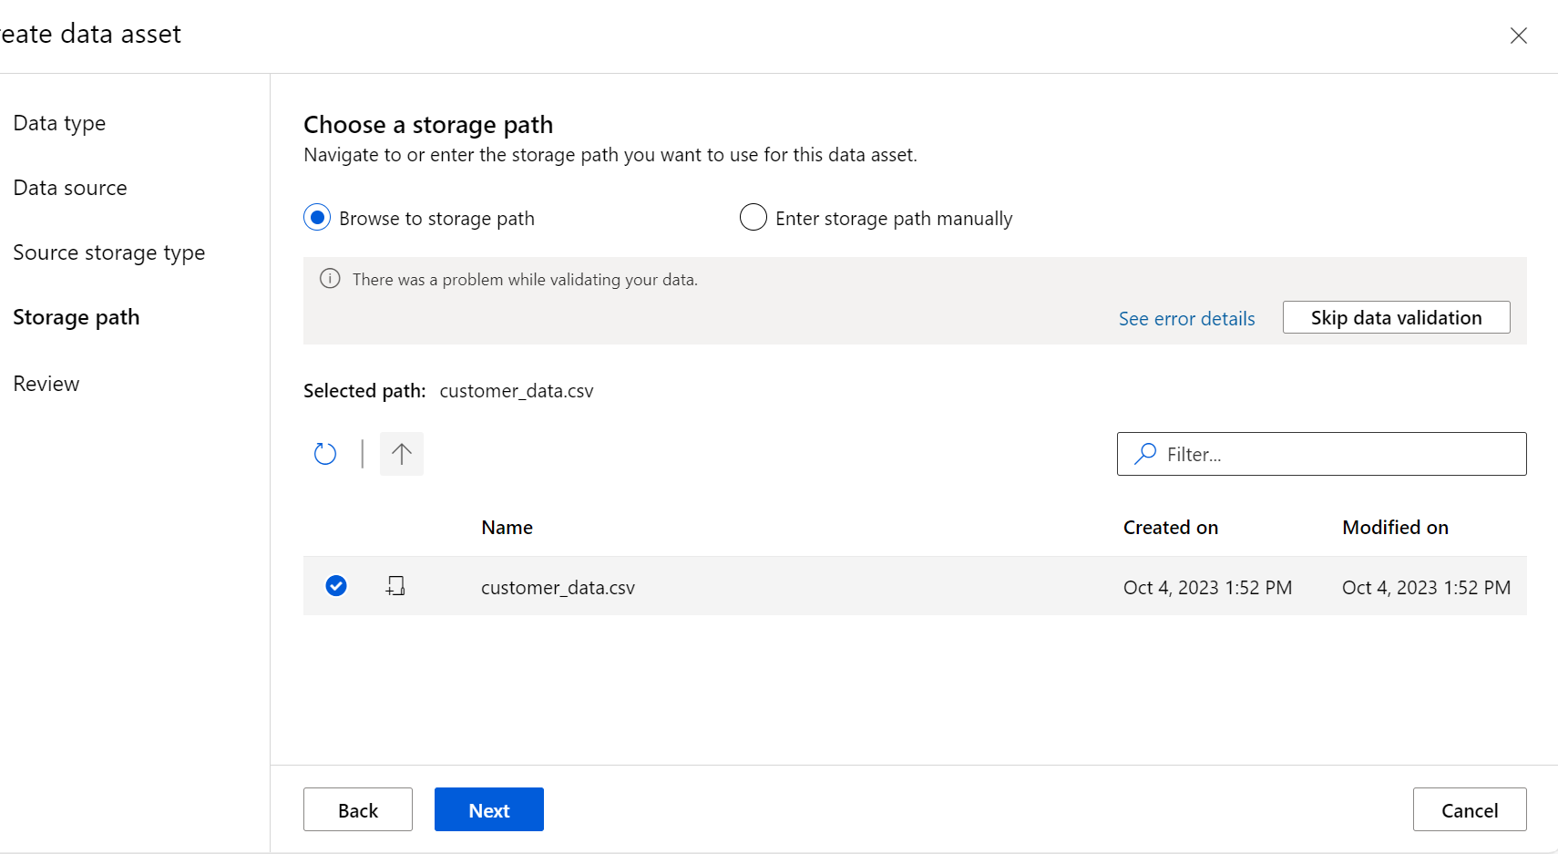

Data asset created

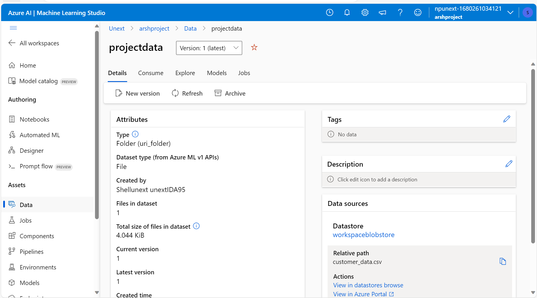

1. Preparing the data

Cleaning missing data

**Model Development**

Splitting data into train and test (70/30)

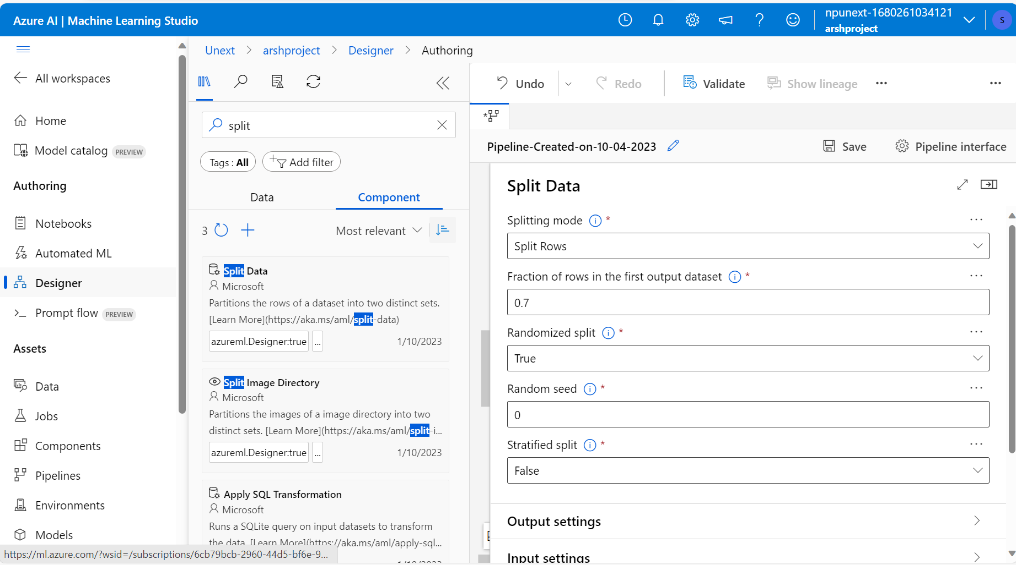

Using regression model

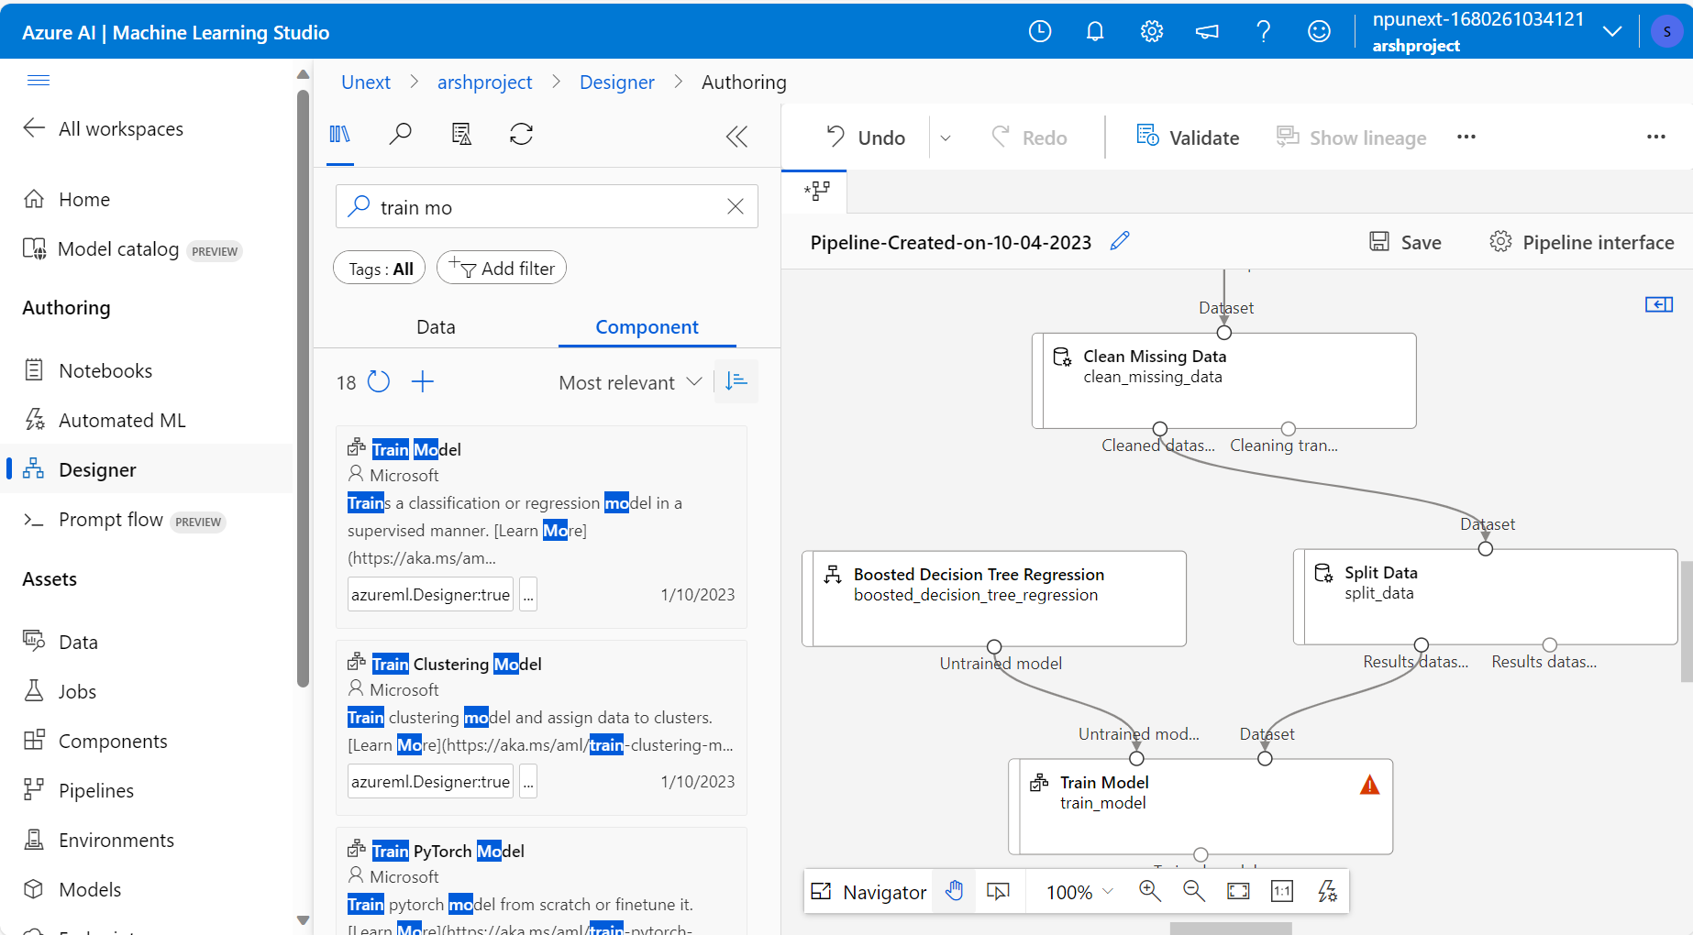

Training the model on selected SpendingScore feature from test data

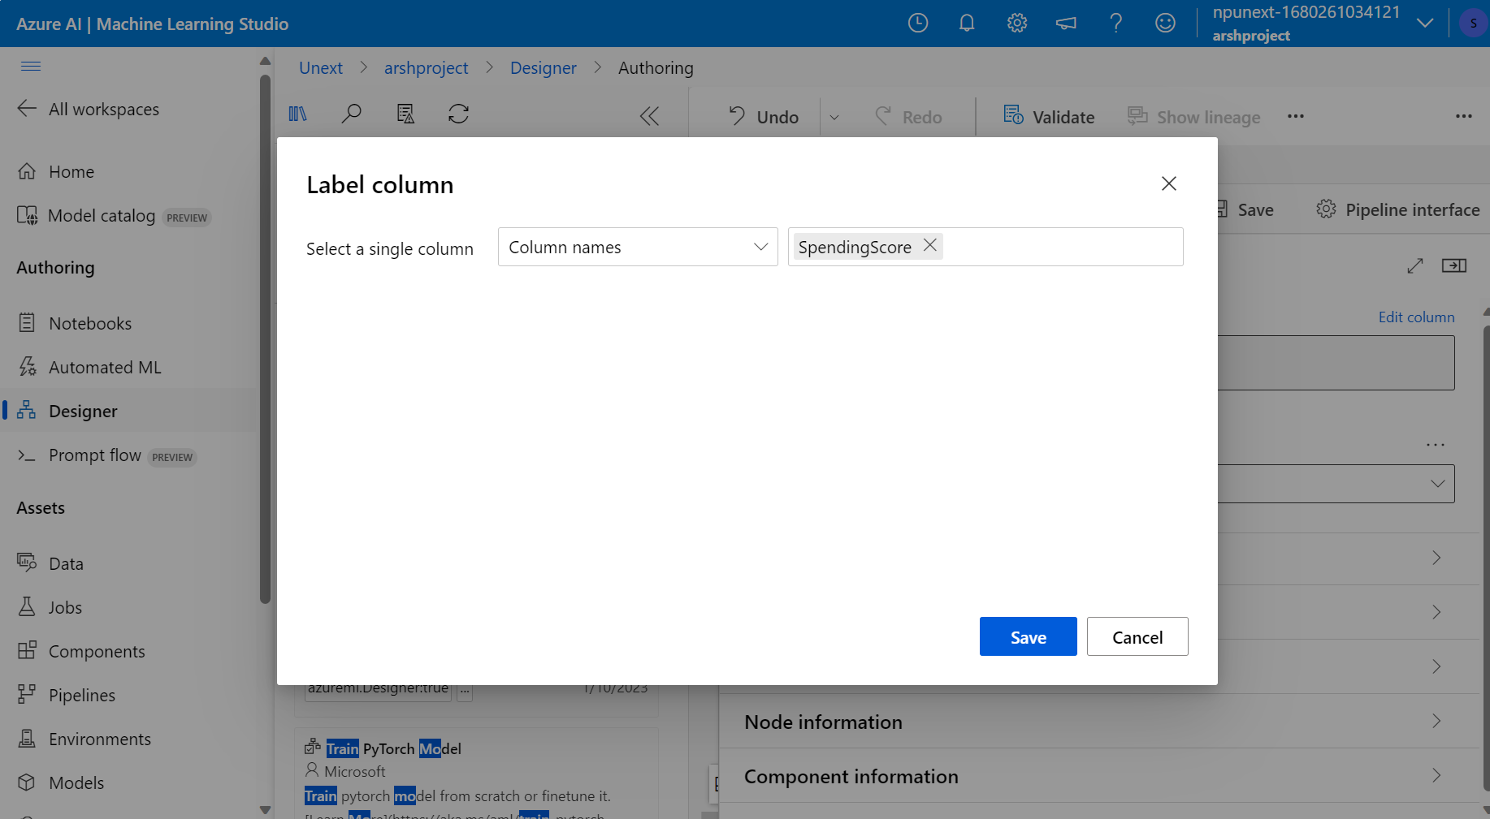

Final pipeline

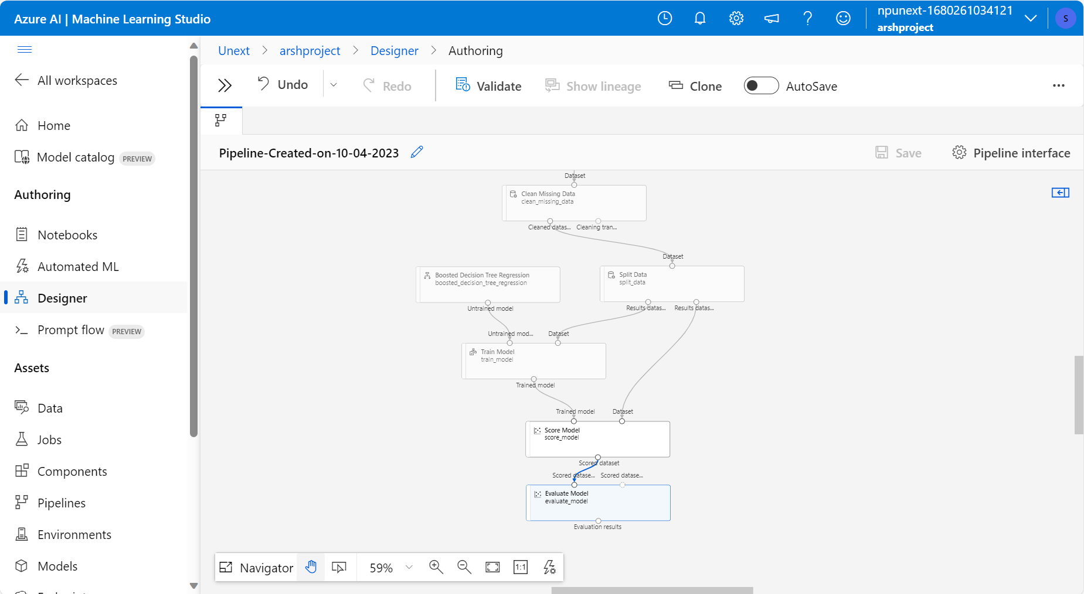

Creating compute cluster

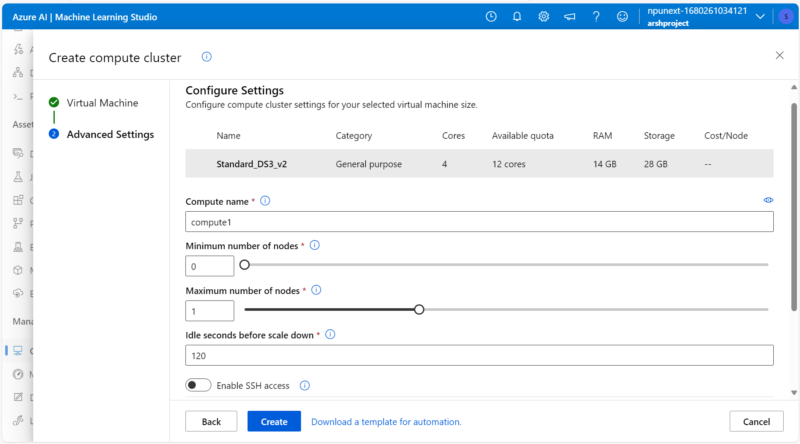

Running and checking the score

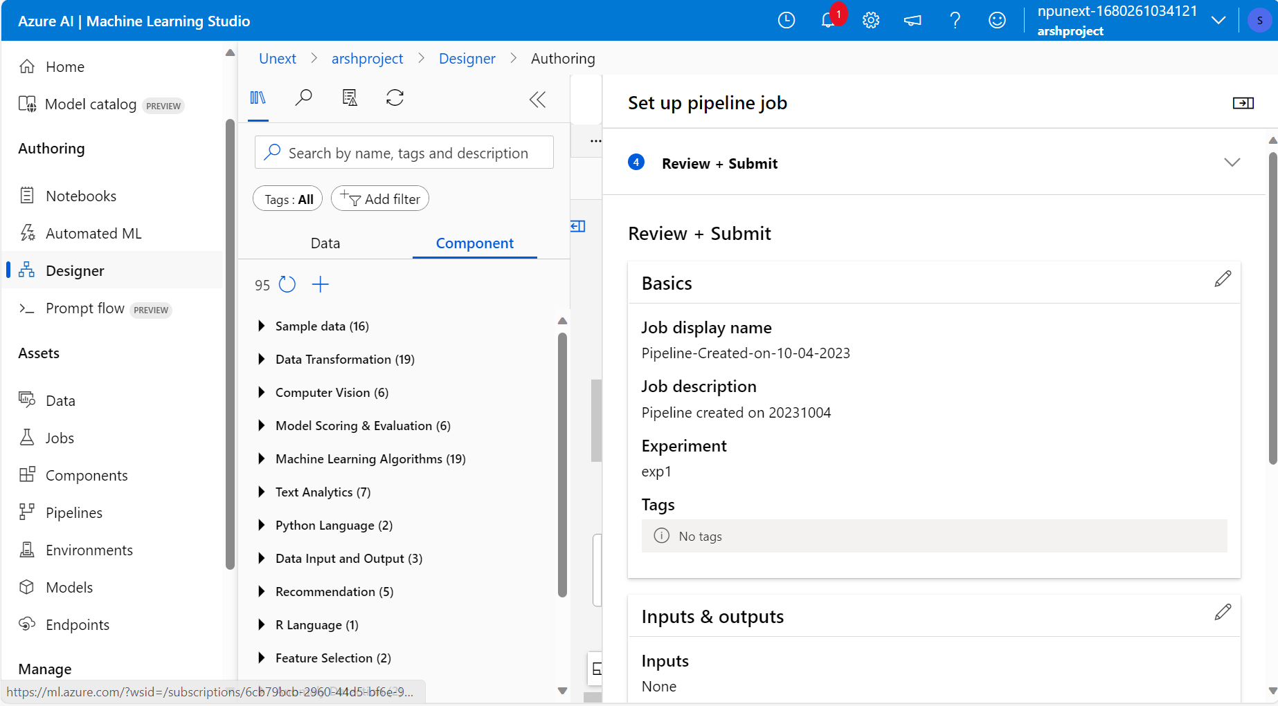

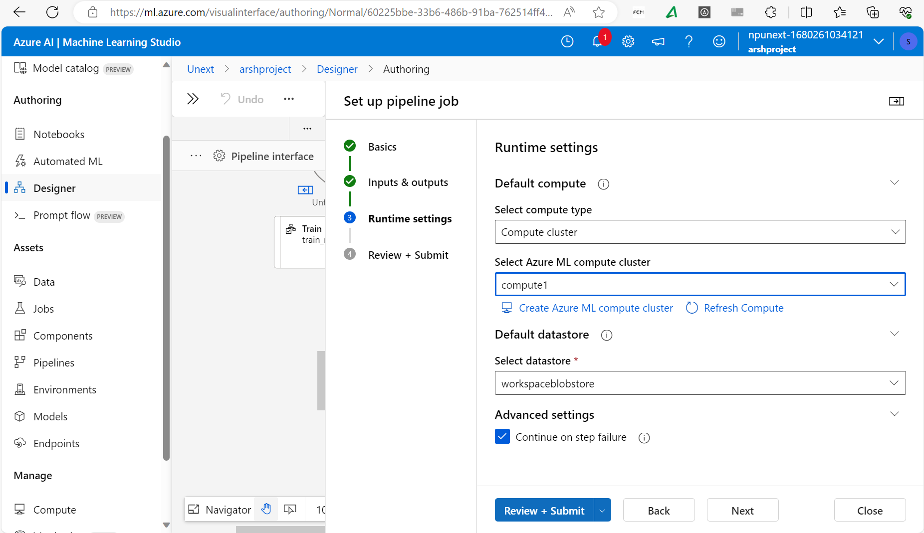

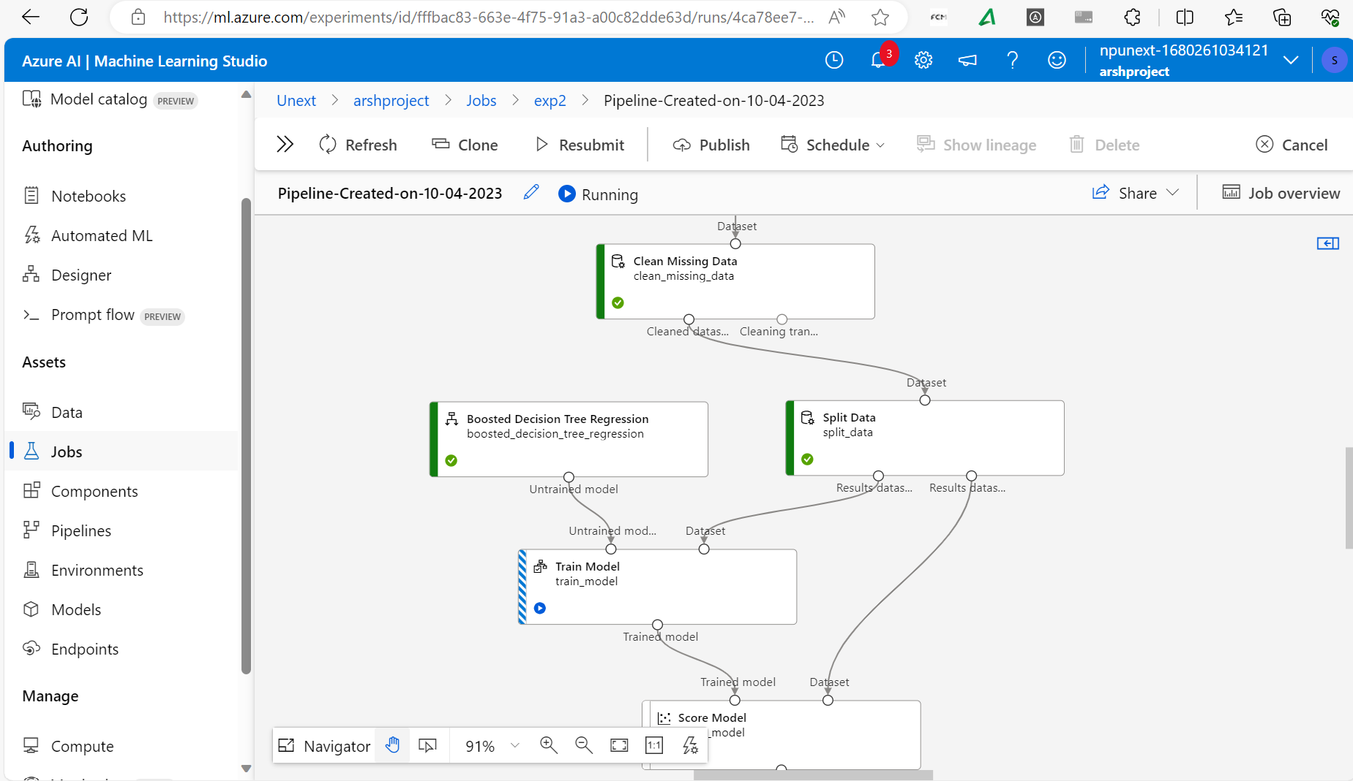

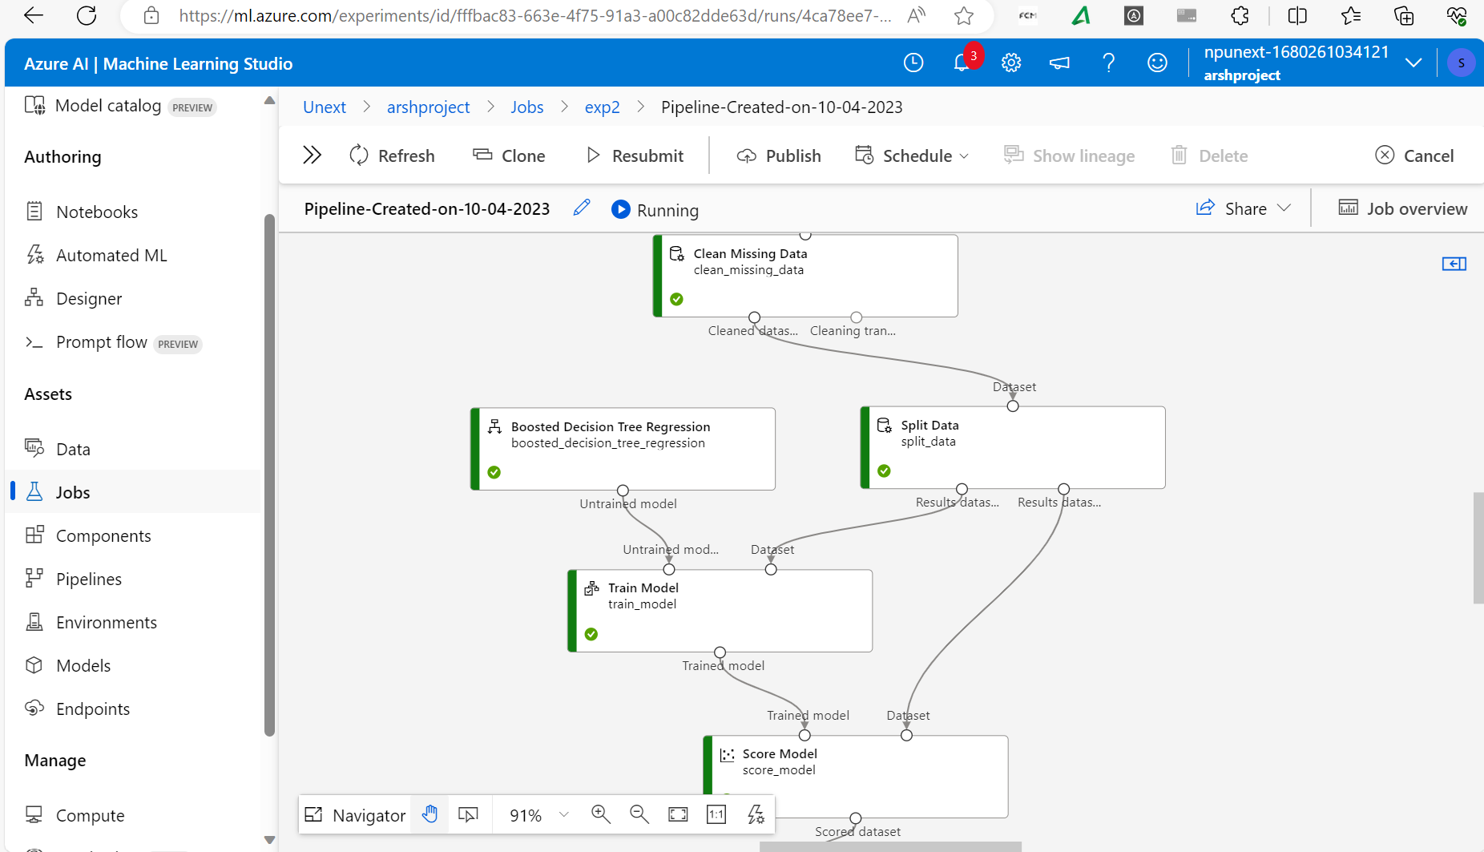

Score

Hyperparameter

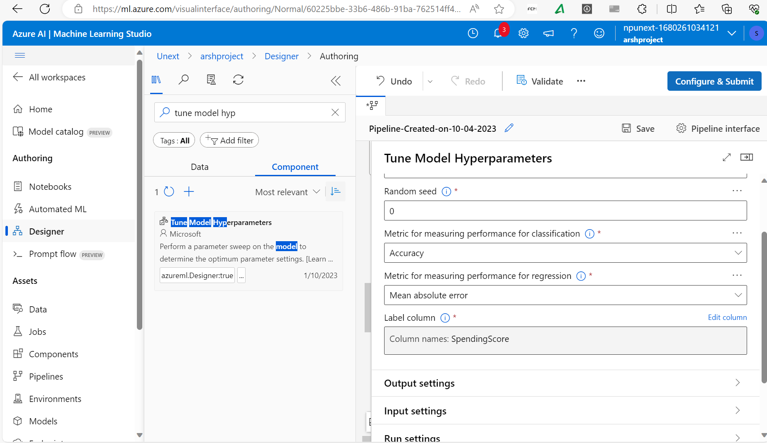

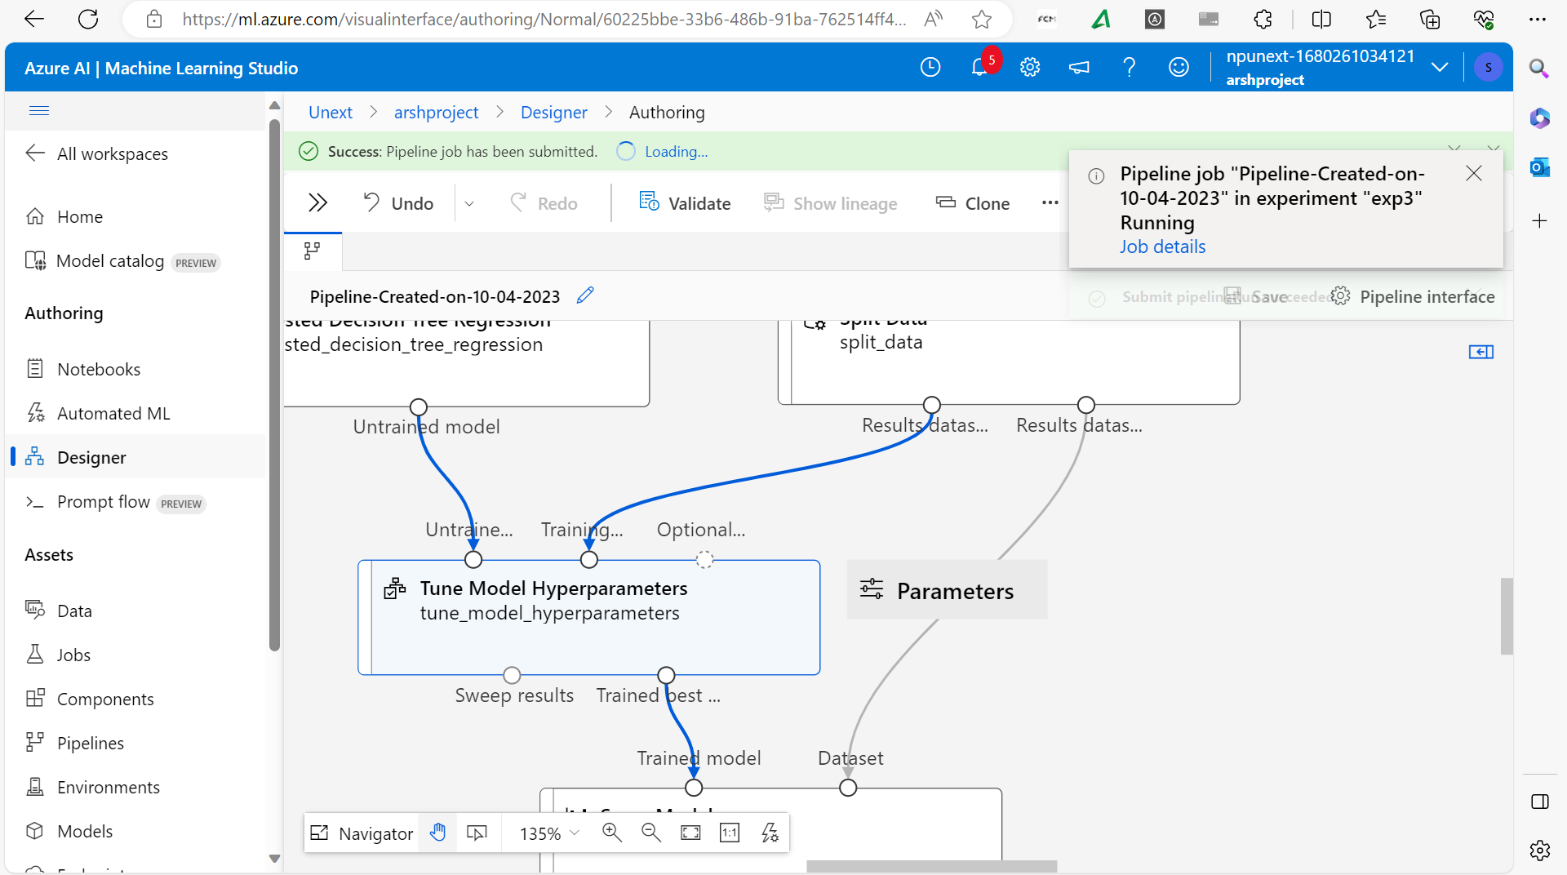

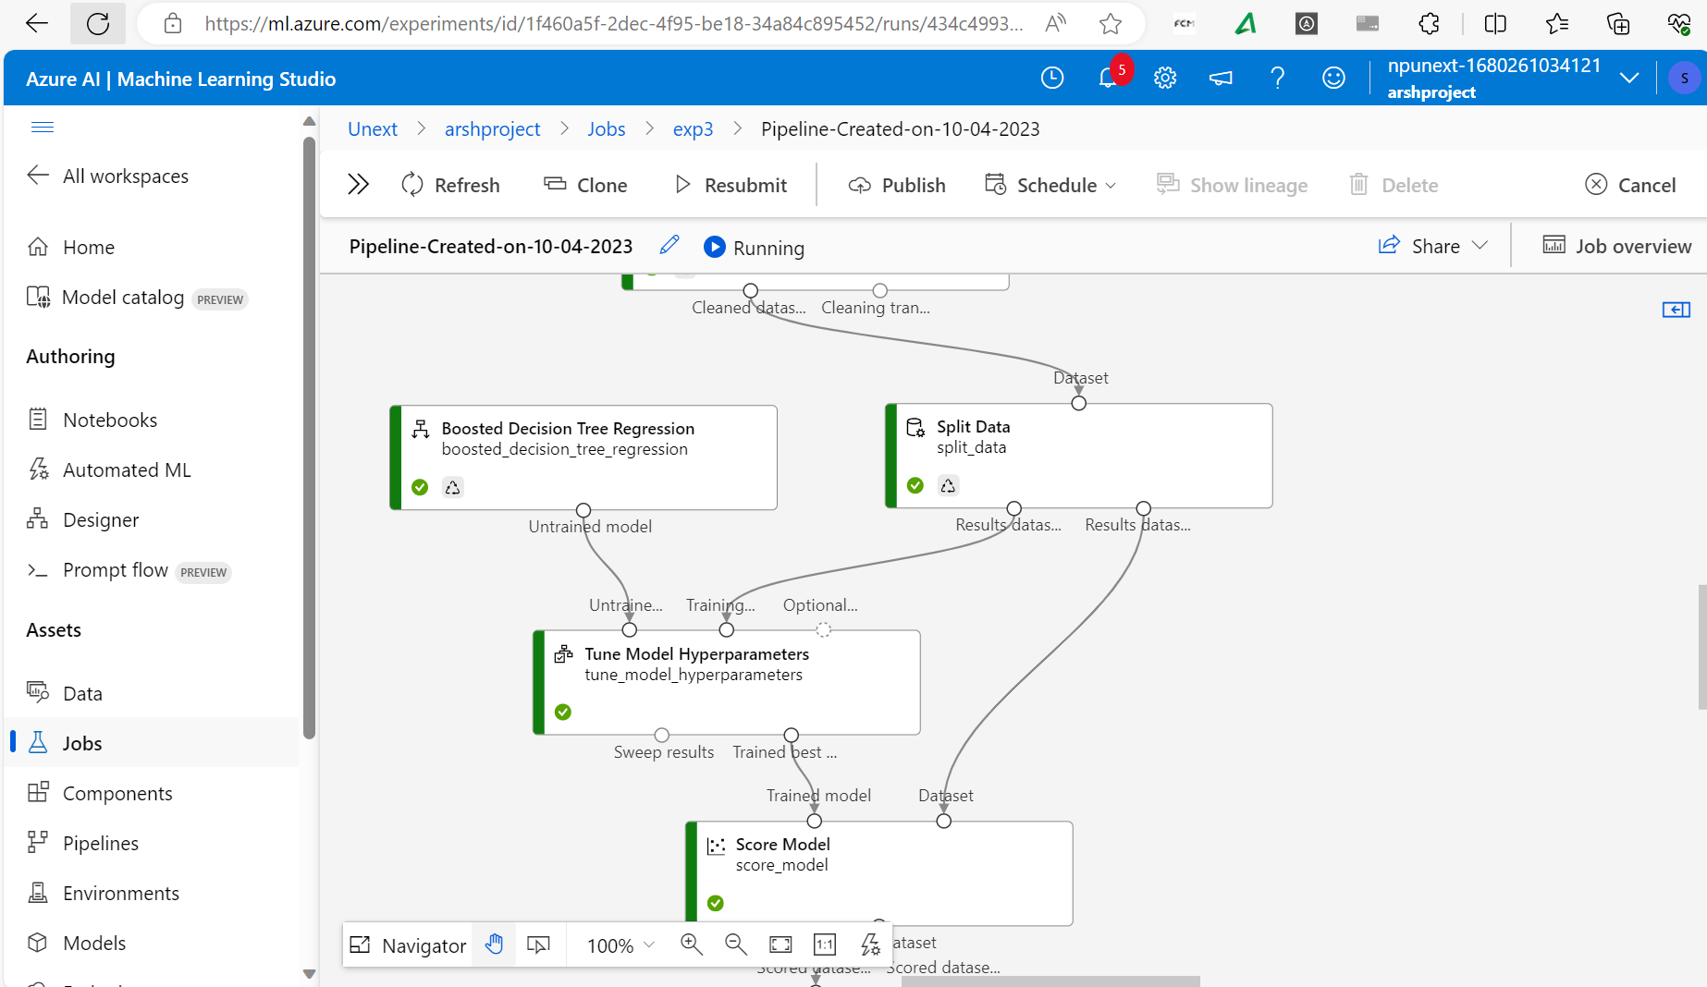

**Assessment answers**

1. The key steps involved in preparing the dataset for training a machine learning model are:
2. Creating a Machine Learning workspace. Blob storage is made by default. Adding a csv file to the default ml container in blob storage account.
3. Launch the ML studio. Create a data asset from azure file.
4. Design a pipeline and clean the data asset using various actions like clean data
5. Split the data after cleaning into train and test sets
6. Pass it to the training model.
7. Splitting into train and test datasets is necessary in order to evaluate the performance of our training model. Our model will be trained on 70% of the dataset and on the rest 30%, since we know how or model should have predicted the answer, we can test the accuracy of our model.
8. We could’ve gone with any regression model since our output is going to be binary. Either the customer purchases(1) or no (0). So if our model predicts percentage of a customer somewhere close to 1 that means he/she buys otherwise not.
9. Hyperparameter tuning is necessary for efficiently training the model and improves its accuracy score